18- ADO.Net -1 DOTNET

1. Create MVC application and display Supplier, Product and Category list. (Used Entity framework to bind data from DB)

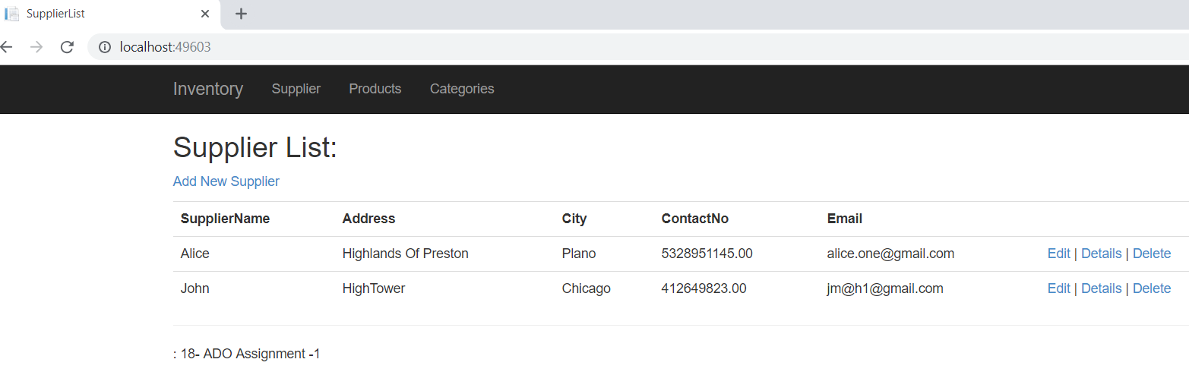

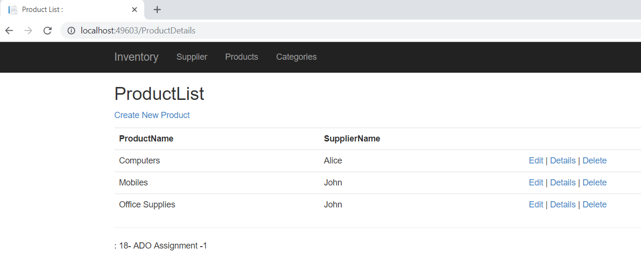

Categories with Search functionality

